D O N G L O N G
MIDDLE EAST

DONGLONG COMPANY PROFILE
DONGLONG creates premium hospitality textiles that enhance comfort, performance, and elegance in every room of the hotel environment. The Donglong name is recognized for advanced textile manufacturing, high quality down and feather processing, and the production of durable luxury bedding solutions. Since its founding in 1992 in Shanghai, the company has evolved into a leading global supplier of hospitality linens for the bed, bath, and guest room.

The enduring strength of DONGLONG lies in its large-scale manufacturing capability, technical innovation, and commitment to superior raw materials. DONGLONG textile specialists apply modern production technology to process down, weave fabrics, and finish every product to strict specifications, ensuring lasting comfort, hygiene, and resilience in demanding hospitality settings.

DONGLONG products are supplied to international markets across Europe, North America, and Asia, serving hotel groups, resorts, and large-scale projects. The company supports hospitality environments where consistency, durability, and guest comfort are essential, delivering textile solutions that meet global standards for performance and reliability.

THE DONGLONG STORY
The history of DONGLONG began in 1992 with a clear focus on integrated textile production. From the beginning, the company developed expertise in feather and down processing, fabric production, and finished bedding manufacturing. This vertical integration allowed DONGLONG to control quality at every stage, from raw material to finished hospitality product.

As global hospitality standards advanced, DONGLONG expanded its production capacity, technology, and export reach. Continuous investment in modern machinery, skilled workforce development, and material sourcing enabled the company to supply high volume projects while maintaining consistent product quality and technical precision.

In the decades that followed, Donglong strengthened its position as a comprehensive hospitality textile manufacturer, offering bedding, duvets, pillows, mattress protectors, toppers, and bath textiles designed specifically for hotel operations. Product development focused on comfort, wash durability, structural stability, and long-term performance under commercial laundering conditions.

Today, Dong long Middle East , represented by North Eagle Trading , brings this manufacturing strength and technical expertise to the Middle East hospitality market. Together, they provide tailored textile solutions for luxury hotels, resorts, serviced residences, and large-scale hospitality projects, combining global manufacturing capability with regional service and support.

IFZA Business Park, Dubai Digital Park (DDP), Dubai, UAE Tel/WhatsApp +971 55 705 3444 WhatsApp +971 58 941 2228 INFO@DONGLONGFM.COM

CERTIFICATIONS & COMPLIANCE
Donglong manufacturing facilities operate under internationally recognized quality, safety, environmental, and material responsibility standards, ensuring reliable performance for global hospitality projects.


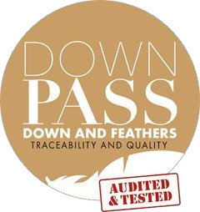





PRODUCT SAFETY & MATERIAL RESPONSIBILITY

OEKO-TEX® STANDARD 100
Textiles tested for harmful substances, confirming fabric safety for direct skin contact and suitability for hospitality environments.
GLOBAL RECYCLED STANDARD (GRS)
Verifies recycled material content and responsible production practices, supporting sustainable sourcing initiatives.
DOWNPASS CERTIFICATION
Certified traceability and quality control for down and feather fillings, ensuring responsible sourcing and verified material standards.
INTEGRATED MANAGEMENT SYSTEMS

ISO 9001 – Quality Management System Ensures standardized production processes and consistent product quality.
ISO 14001 – Environmental Management System
Demonstrates responsible environmental practices in manufacturing operations.
ISO 45001 – Occupational Health & Safety Management Confirms safe and controlled working conditions within production facilities.

ISO 50001 – Energy Management System Supports efficient energy use and sustainable manufacturing performance.

All certifications are valid and available for verification upon request.

HOTEL FABRIC INFORMATION
Understanding Hospitality Textile Standards
Hospitality textiles are engineered to balance comfort, durability, and performance under frequent commercial laundering. The following fabric characteristics help define product feel, strength, and suitability for different hotel room categories.

YARN COUNT
Yarn count refers to the thickness of individual threads used in fabric construction. Higher numbers indicate finer yarns, while lower numbers provide increased durability.
Yarn  Count | Fabric Feel | Typical Use in Hospitality
40S | Strong, durable, practical | High-use rooms, frequent laundering environments
60S | Softer, smoother surface | Premium room categories
80S | Fine, refined, luxurious feel | Luxury hospitality and high-end suites

THREAD COUNT (TC)
Thread count represents the number of threads woven into one square inch of fabric. In hospitality textiles, balance between softness and durability is essential.
Thread Count Range | Performance Characteristics
200–250 TC | Breathable, strong, highly durable
300 TC | Balanced softness and resilience
400 TC+ | Smoother touch with premium surface finish
Hospitality fabrics prioritize durability, wash resistance, and long-term performance over excessive thread density.

WEAVE TYPES
The weaving method affects fabric texture, appearance, and performance.
Weave Type | Characteristics | Best Suited For
Plain Weave | Crisp feel, breathable, long-lasting | Standard hotel bedding
Sateen | Smooth surface, soft hand feel, subtle sheen | Premium room collections
Stripe Sateen | Elegant woven stripe design | Upscale hospitality environments
Jacquard | Decorative patterns woven into fabric | Luxury and decorative bedding lines

FABRIC COMPOSITION
Material selection influences breathability, maintenance, and performance.
Material | Benefits in Hospitality Use
100% Cotton | Natural comfort, breathability, softness
Poly-Cotton | Easy care, wrinkle resistance, practical durability
Down-Proof Cotton | Prevents feather leakage in duvets and pillows

HOSPITALITY SUPPLY CAPABILITY

Donglong Middle East supports structured hospitality supply programs designed for large-scale hotel operations, renovations, and multi-property projects.

Production Capacity Raw Material Processing
Category | Annual Capacity
Down | 5,000 tons / year
Feather | 5,000 tons / year
Bleached Fabric | 50 million meters / year
Printed Fabric | 6 million meters / year

Finished Product Output
Product | Weekly Capacity
Down & Feather Quilts | 50,000 pcs / week
Synthetic Quilts | 50,000 pcs / week
Down & Feather Pillows | 50,000 pcs / week
Synthetic Pillows | 50,000 pcs / week
Cushions | 250,000 pcs / week
Cushion Covers | 50,000 pcs / week
Chair Pads | 50,000 pcs / week
Bedspreads / Blankets | 14,000 pcs / week
Sofa Covers | 75,000 pcs / week

Operational Strengths
- Bulk project supply
- Pre-production sampling
- Custom sizing
- Labeling & branding
- Repeat order consistency
- Direct factory supply model

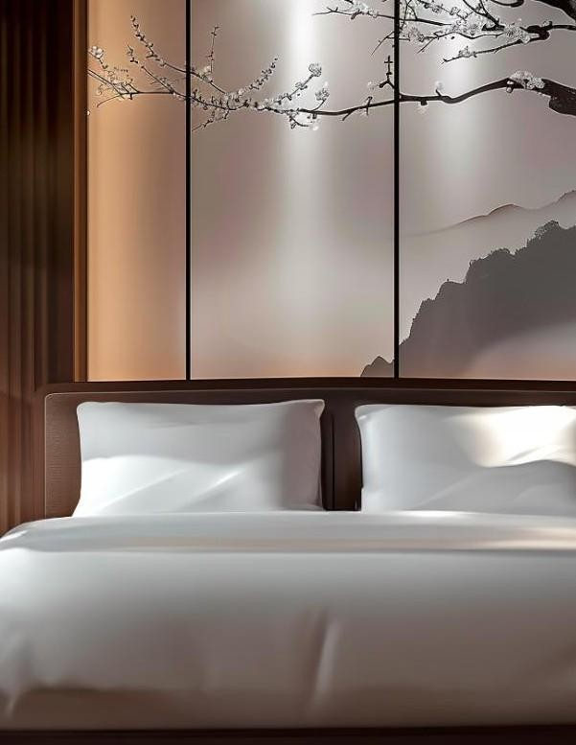

DONGLONG BED LINENS

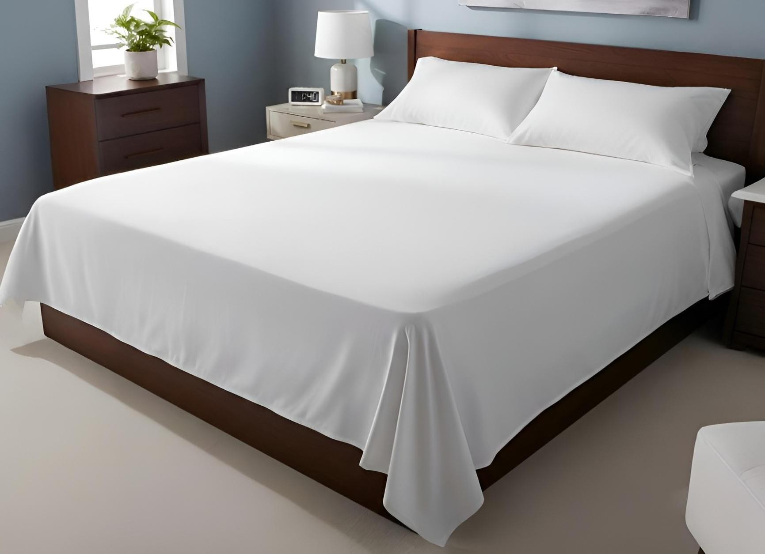

FLAT BED SHEET COLLECTION
SPECIFICATIONS
Fabric Composition
Pure Cotton or Poly Cotton
Yarn Count
40S / 60S / 80S
Weave Types
Plain Sateen
Stripe Sateen Jacquard Thread Density
200–400 TC or customized
Construction
1 cm folded hem on four sides or customized finish
Color Options
White and customized solid colors
Sizes
Single / Twin / Double / Queen / King / Custom
Crafted for professional hospitality environments, our flat bed sheets combine refined fabric construction with long term operational durability. Designed to withstand repeated commercial laundering while maintaining softness and structure, these sheets deliver consistent comfort, a smooth sleeping surface, and a clean presentation that meets the standards of luxury hotels.
Engineered using carefully selected yarns and weaving techniques, the collection supports both premium guest rooms and high-volume projects, offering a balance between elegance, resilience, and ease of maintenance.

FITTED BED SHEET COLLECTION
SPECIFICATIONS
Fabric Composition
Pure Cotton or Poly Cotton
Yarn Count
40S / 60S / 80S
Weave Types
Plain Sateen
Stripe Sateen Jacquard Thread Density
200–400 TC or customized
Construction
Four-corner tailored pockets
Elastic sewn around edges for secure mattress fit
Color Options
White and customized solid colors
Sizes
Single / Twin / Double / Queen / King / Custom
Designed specifically for secure mattress coverage in hospitality environments, our fitted bed sheets combine precision tailoring with durable fabric construction. The fitted design ensures a smooth, tight surface that prevents shifting during guest use, maintaining a neat bed presentation while protecting the mattress.
Built to endure frequent commercial laundering, these sheets retain elasticity, shape, and fabric
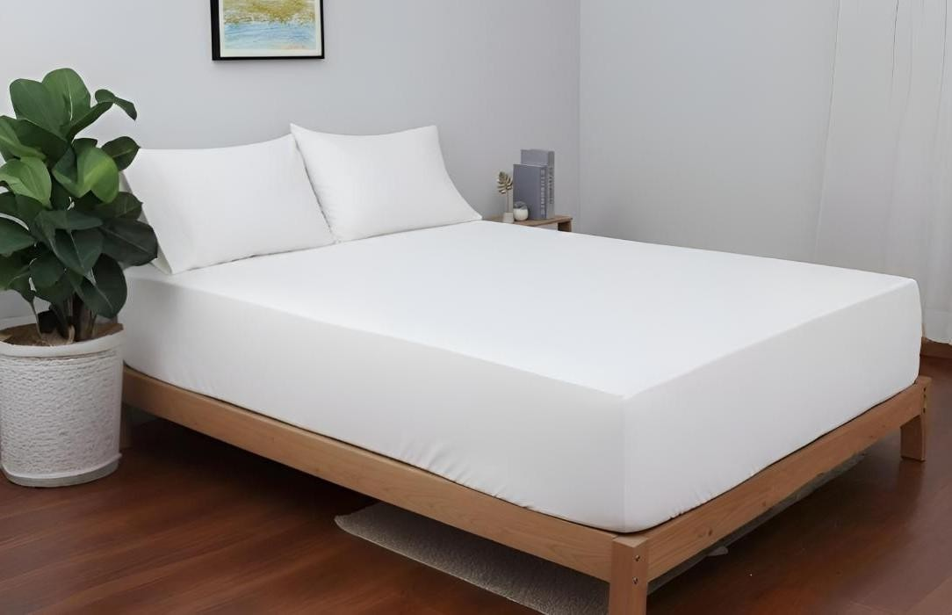
integrity over time, making them ideal for luxury hotels, serviced residences, and high occupancy properties where both appearance and longevity are essential.

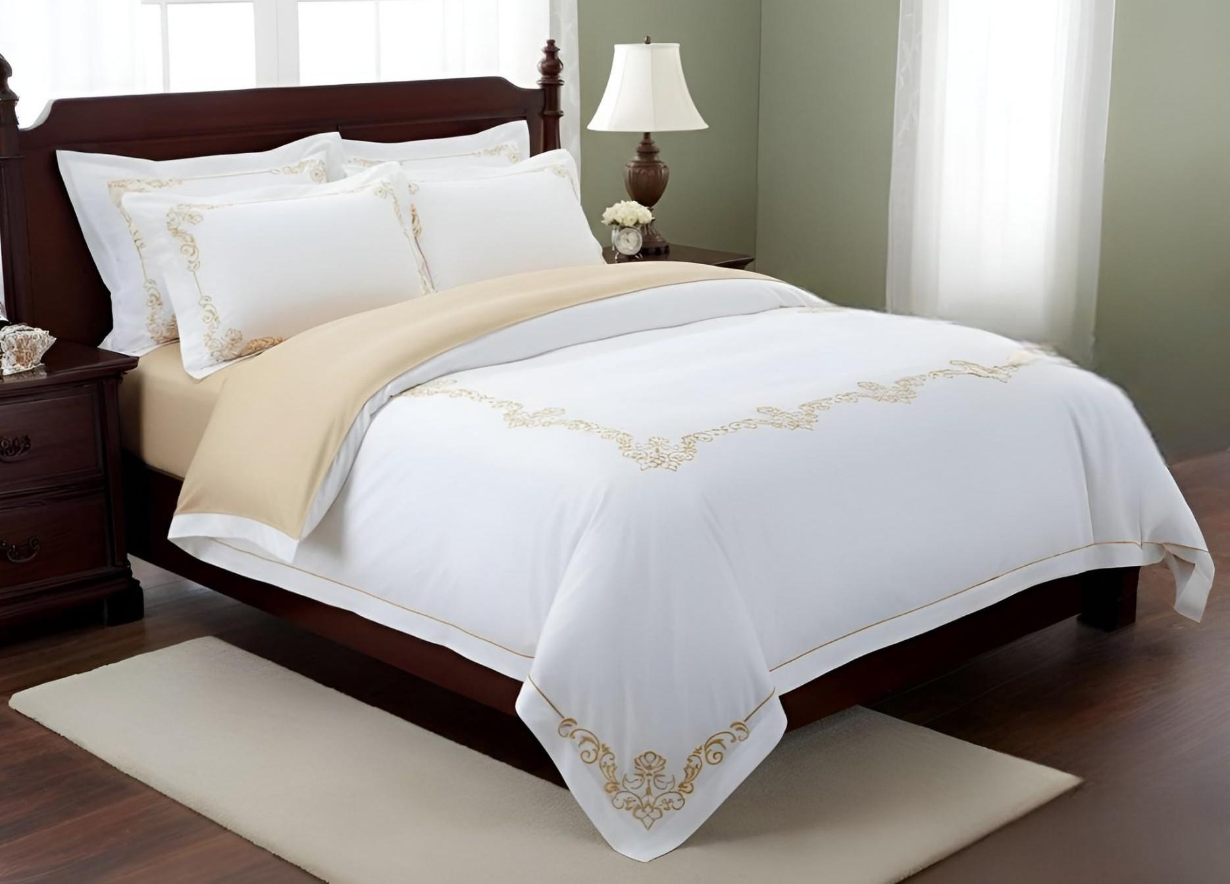

EMBROIDERY FLAT BED SHEET COLLECTION
SPECIFICATIONS
Fabric Composition
Pure Cotton or Poly Cotton
Yarn Count
40S / 60S / 80S
Weave Types
Plain Sateen Jacquard
Thread Density
200–400 TC or customized Embroidery Options Decorative borders
Logo embroidery Custom patterns Construction
1 cm folded hem or customized finishing
Color Options
White and customized colors
Sizes
Single / Twin / Double / Queen / King / Custom
Customization
Logo / Label / Size / Color / Embroidery Design
Designed to elevate the visual character of hospitality bedding, our embroidery flat bed sheets combine refined textile construction with decorative detailing. Subtle embroidered patterns introduce elegance and distinction to the guest room while preserving the durability required for commercial laundering.
The embroidery process enhances the aesthetic appeal of the bed presentation without compromising fabric performance, making this collection ideal for luxury suites, premium guest rooms, and high-end hospitality environments seeking a distinctive textile finish.

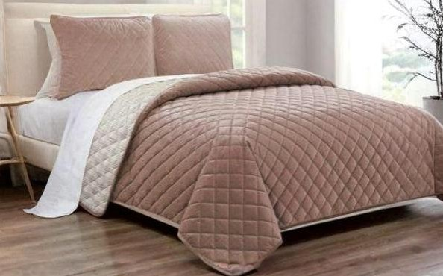
DUVET COVER COLLECTION
SPECIFICATIONS
Fabric Composition
Pure Cotton or Poly Cotton
Yarn Count
40S / 60S / 80S
Weave Types Plain Sateen Stripe Sateen Jacquard Thread Density
200–400 TC or customized
Closure Styles Bag Style Envelope Style Opening Design Side opening
Back opening with inner flap
Color Options
White and customized solid colors
Sizes
Single / Twin / Double / Queen / King / Custom
Customization
Logo / Label / Size / Color / Pattern
Designed for hospitality presentation and operational durability, our duvet covers combine refined textile finishes with structural performance. Acting as the visible outer layer of the duvet system, these covers enhance the overall bed appearance while protecting the insert from wear, soiling, and repeated laundering. The collection supports both premium room aesthetics and efficient housekeeping operations, making it suitable for luxury guest rooms as well as large scale hotel projects. Engineered with carefully selected yarns and weave constructions, the duvet covers maintain fabric integrity, softness, and shape retention under commercial laundry conditions. Multiple closure systems and construction styles allow properties to choose the most suitable solution for room category, housekeeping workflow, and long-term performance requirements.

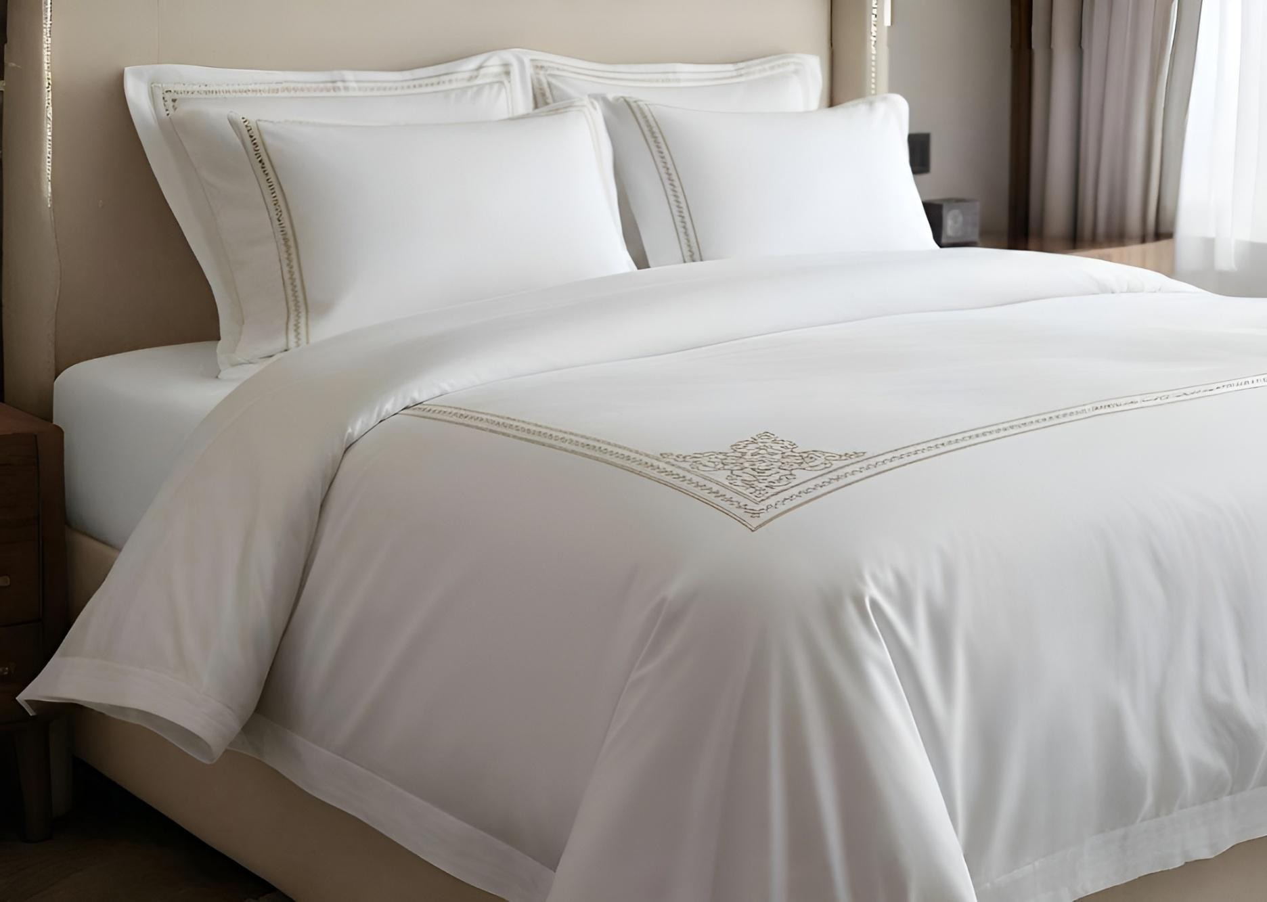

EMBROIDERY DUVET COVER COLLECTION
SPECIFICATIONS
Fabric Composition
Pure Cotton or Poly Cotton
Yarn Count
40S / 60S / 80S
Weave Types Plain Sateen Jacquard Thread Density
200–400 TC or customized Embroidery Options Decorative borders
Logo embroidery Custom patterns Closure Styles Bag Style Envelope Style Color Options
White and customized colors
Sizes
Single / Twin / Double / Queen / King / Custom
Customization
Logo / Label / Size / Color / Embroidery
Created for hospitality environments seeking elevated textile presentation, our embroidery duvet covers introduce refined decorative detailing while maintaining the durability required for commercial use. The embroidered finish adds visual distinction to the bed, enhancing the guest room atmosphere without compromising structural performance.
Designed to withstand frequent laundering, the embroidery maintains clarity, shape, and fabric integrity over time. This collection is ideal for luxury suites, premium room categories, and hospitality spaces where subtle textile detailing contributes to a higher level of interior refinement.

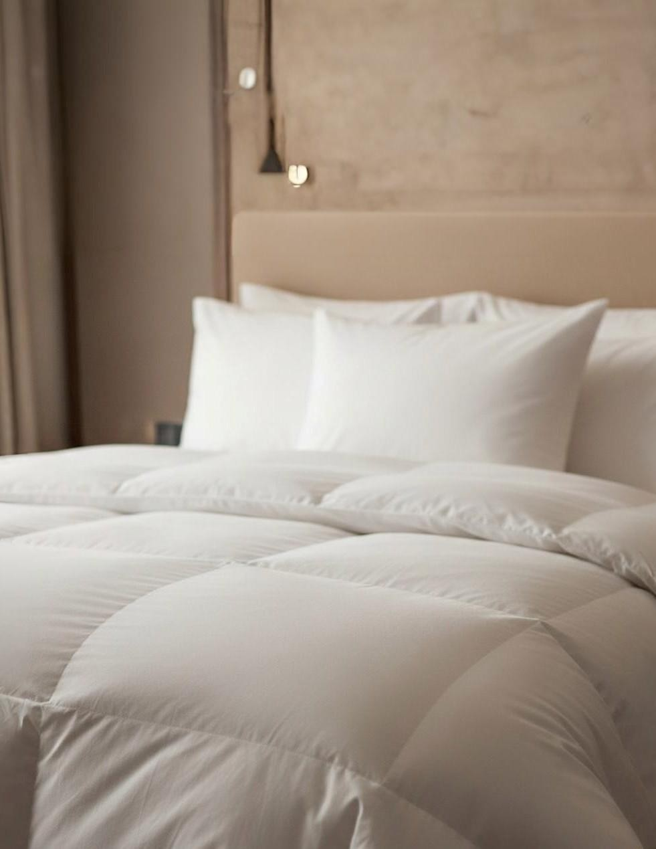

DONGLONG DOWN PRODUCTS

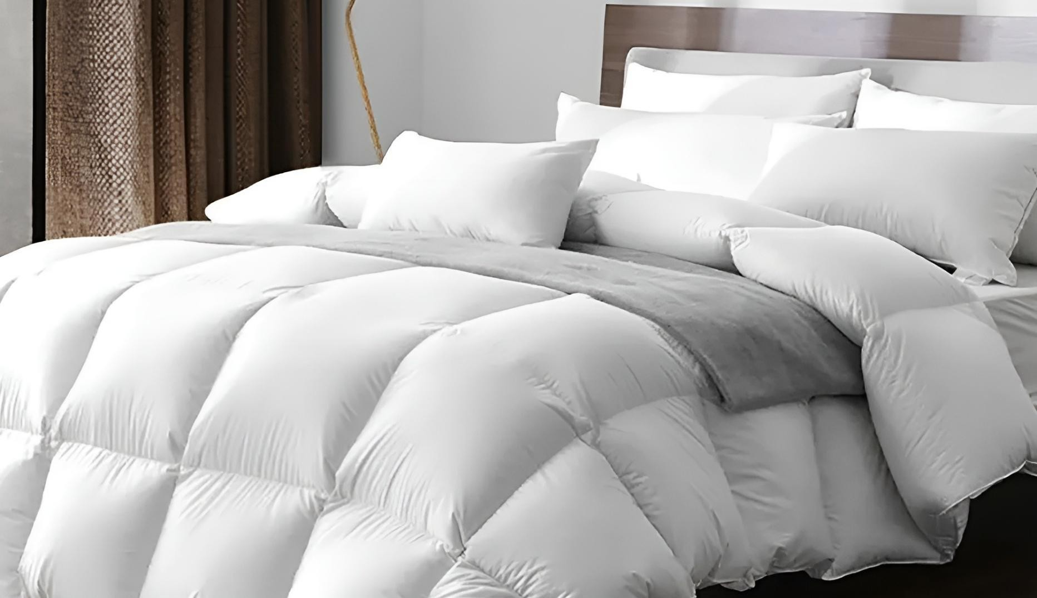
DUVET INSERT COLLECTION
SPECIFICATIONS
Outer Fabric
Pure Cotton or Poly Cotton down-proof fabric
Filling Options Microfiber
White or gray duck down White or gray goose down Down Content Options
50%–90% down content (for down duvets)
Construction Styles
Cutting through box technique Baffled box design
Knife edge stitching
Single or double stitch with piping edge Color
White Customization
Down content / Filling weight / Logo label
Engineered to provide comfort, insulation, and long-term resilience in hospitality environments, our duvet inserts form the core of the bedding system. Designed for consistent loft, temperature regulation, and durability under commercial laundering conditions, the collection offers solutions for various climate needs and room categories.
By combining advanced microfiber filling technologies with natural down options, Donglong provides both functional and premium comfort systems. The inserts are constructed to maintain structure, prevent filling displacement, and deliver a balanced sleeping experience that supports luxury hotel standards.

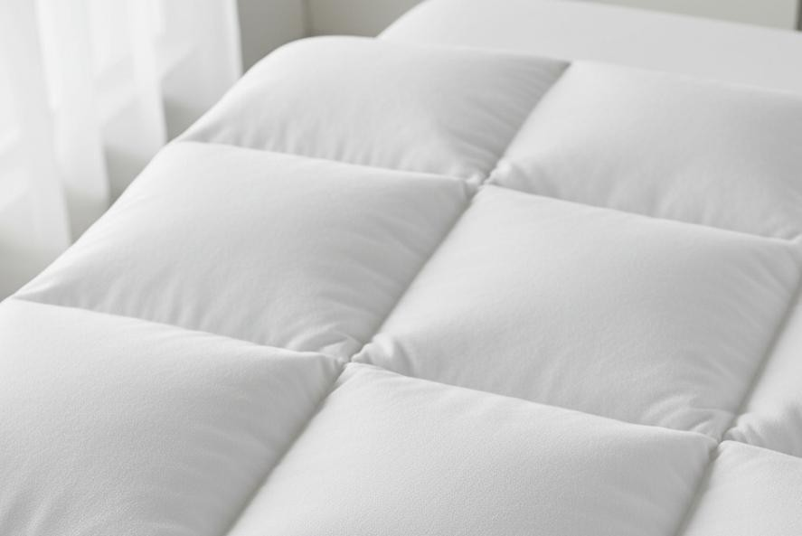
SPECIFICATIONS
Outer Fabric
Pure Cotton fabric (also available: Pure Cotton or poly plain fabric)
Filling
Microfiber (filling weight customized)
Construction
Knife edge stitching Sewn-through box design
Single needle or double-needle stitching Piping edge option
Color
White
Logo & Label
Embroidery / Print / Jacquard logo

MICROFIBER DUVET INSERTS
Designed for durability, ease of care, and consistent performance, our microfiber duvet inserts provide a practical and resilient bedding solution for hospitality environments. Engineered to maintain loft, shape, and insulation through frequent commercial laundering, these inserts deliver reliable comfort while supporting efficient hotel operations.
Microfiber filling offers a lightweight, hypoallergenic alternative to natural down, making it suitable for high occupancy properties and environments requiring simplified maintenance. The construction methods ensure even filling distribution and structural integrity, allowing the insert to retain its form and performance over time.

CONSTRUCTION STYLES INCLUDED
Knife Edge Style
A clean, minimal finish with secure inseam stitching, offering a smooth appearance and reliable structure for everyday hospitality use.
Single or Double Stitch with Piping Edge
Reinforced edge construction with decorative piping, enhancing durability and providing a refined visual finish suitable for premium room categories.

USE APPLICATION
Ideal for hotels, resorts, serviced residences, and large-scale hospitality properties where durability, hygiene, and ease of maintenance are key operational requirements.

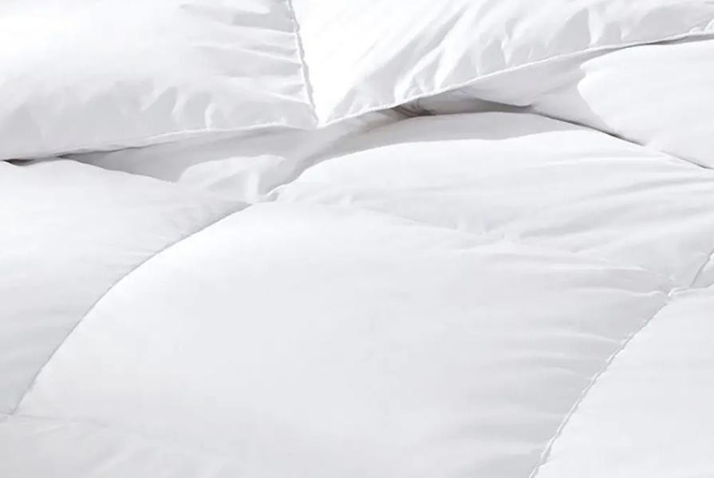
SPECIFICATIONS
Outer Fabric
Pure Cotton down-proof fabric
Filling
White or gray duck down / goose down
Down Content
50%–90% down content (customized)
Construction
Single needle or double needle + binding sewing Cutting-through technique
Color
White
Logo & Label
Embroidery / Print / Jacquard logo

DOWN DUVET INSERTS
Crafted for hospitality environments seeking natural insulation and elevated comfort, our down duvet inserts provide exceptional softness, warmth regulation, and breathability. The natural down filling adapts to varying room temperatures, creating a balanced sleeping experience that meets the expectations of luxury hotel guests.
Designed for structural reliability, the inserts maintain loft and shape through commercial laundering while offering superior thermal performance. This collection is ideal for premium room categories, suites, and hospitality environments where natural comfort and guest satisfaction are prioritized.

CONSTRUCTION STYLES INCLUDED
Cutting Through Construction
A sewn through box construction that secures filling distribution while maintaining a lightweight and flexible structure. This method provides reliable warmth control and consistent performance, making it suitable for all season hospitality use.

USE APPLICATION
Recommended for luxury hotels, premium guest rooms, and hospitality projects requiring natural fill comfort combined with long term durability.

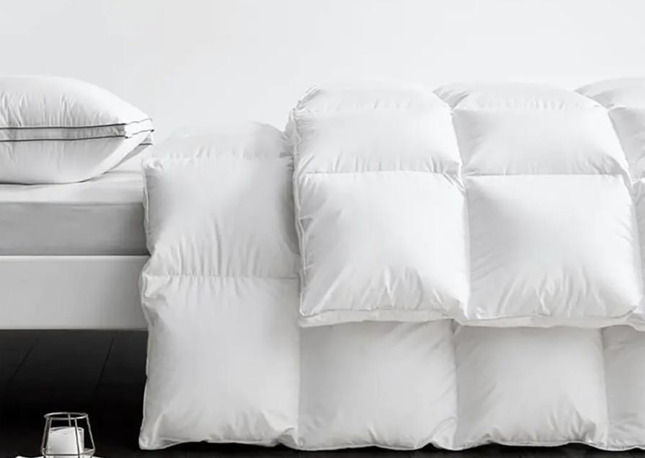
SPECIFICATIONS
Outer Fabric
Pure Cotton down-proof plain fabric or Polyester down-proof plain fabric Filling
White or gray duck down / goose down
Down Content
50%–90% down content (customized)
Construction
Single needle or double needle + binding sewing Baffled box design
Color
White
Logo & Label
Embroidery / Print / Jacquard logo

BAFFLED BOX DOWN DUVET
Engineered for maximum loft, insulation efficiency, and long-term performance, the baffled box construction represents the most advanced structure within the down duvet range. Unlike sewn through designs, internal fabric walls create three-dimensional chambers that allow the down to expand fully, delivering superior warmth, breathability, and consistent distribution.
This construction minimizes cold spots, enhances thermal performance, and preserves the natural loft of the down over time. The result is a premium sleeping experience suited to luxury hospitality environments where guest comfort and bedding quality are central to room standards.

CONSTRUCTION STYLES INCLUDED
Baffled Box Construction
Internal fabric walls form independent chambers that maintain fill stability while allowing maximum expansion of the down. This structure improves insulation performance, shape retention, and long- term durability.

USE APPLICATION
Recommended for luxury suites, premium room categories, and hospitality environments in cooler climates where maximum loft and insulation performance are required.

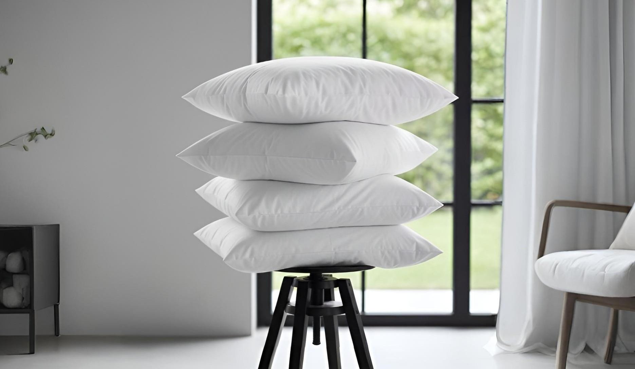

PILLOW INSERT COLLECTION
SPECIFICATIONS
Outer Fabric
Pure Cotton down-proof plain fabric Filling Options
Microfiber
White or gray duck down White or gray goose down Down Content Options 20%– 70% down content (customized) Construction Styles
Knife edge stitching
Single or double stitch with piping edge Single chamber technique Three chamber technique Color
White (piping optional) Customization Down content / Filling weight / Logo label
Engineered to support guest comfort and long-term durability, our pillow inserts provide balanced loft, structural resilience, and consistent performance in hospitality environments. Designed to maintain shape and support through frequent commercial laundering, the collection offers solutions for varying comfort preferences and room categories.
By combining advanced microfiber filling technologies with natural down constructions, Donglong ensures
properties can select appropriate comfort levels while maintaining operational efficiency. Each insert is built to prevent filling displacement and preserve pillow structure, delivering a refined sleeping experience aligned with premium hospitality standards.

MICROFIBER PILLOW INSERTS
SPECIFICATIONS
Outer Fabric
Pure Cotton down-proof plain fabric
Filling
Microfiber (filling weight customized)
Construction
Knife edge (simple seam sewing) Single needle / Double-needle Piping edge option
Color
White (piping color optional)
Logo & Label
Embroidery / Print / Jacquard logo
Engineered to support guest comfort and long-term durability, our pillow inserts provide balanced loft, structural resilience, and consistent performance in hospitality environments. Designed to maintain shape and support through frequent commercial laundering, the collection offers solutions for varying comfort preferences and room categories.
By combining advanced microfiber filling technologies with natural down constructions, Donglong ensures properties can select appropriate comfort levels while maintaining operational efficiency. Each insert is built to prevent filling displacement and preserve pillow structure, delivering a refined sleeping experience aligned with premium hospitality standards.

CONSTRUCTION STYLES INCLUDED
Knife Edge Style
A clean edge finish with secure inseam stitching, offering a simple and durable structure suited for everyday hospitality use.
Single or Double Stitch with Piping Edge
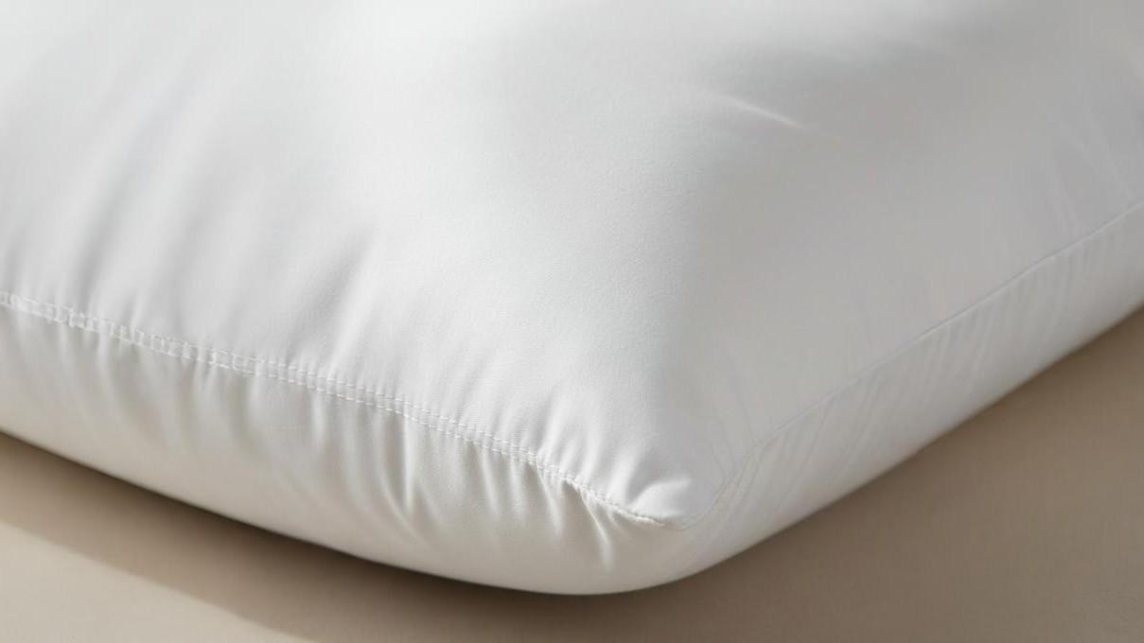
Reinforced edge construction with decorative piping, enhancing durability while providing a refined appearance for premium room categories.

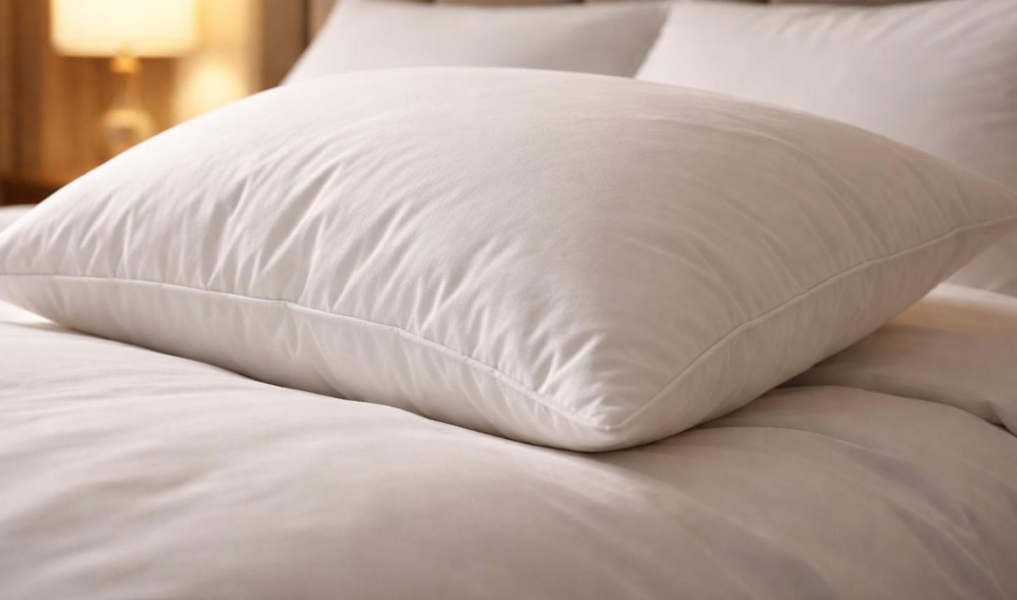

DOWN PILLOW INSERTS
SPECIFICATIONS
Outer Fabric
Pure Cotton down-proof plain fabric
Filling
White or gray duck down / goose down
Down Content
20%–70% down content (customized)
Construction Styles
Single chamber technique
Three chamber technique (inner & outer chambers can differ)
Color
White (with or without piping; piping color optional)
Logo & Label
Embroidery / Print / Jacquard logo
Designed to deliver natural softness and adaptive comfort, our down pillow inserts provide a premium sleep experience suited for elevated hospitality environments. The natural down filling offers breathability, flexibility, and a gentle support profile that responds to guest movement while maintaining loft and shape.
Engineered for durability, these inserts are constructed to retain structural integrity under commercial laundering while preserving the natural performance of the down. This collection is ideal for luxury suites and premium room categories where comfort and guest satisfaction are key priorities.

CONSTRUCTION STYLES INCLUDED

Single Chamber Construction
A uniform filling structure that provides balanced softness and flexibility suitable for all season hospitality use.
Three Chamber Construction
A layered internal structure where outer chambers provide softness while the inner chamber delivers support, creating a combination of comfort and shape retention for premium applications.

MATTRESS TOPPER COLLECTION
SPECIFICATIONS
Outer Fabric
Pure Cotton plain fabric
Pure Cotton down-proof plain fabric
Filling Options
100% Microfiber
Duck down / Goose down
Down Content (for down toppers) 5%–30% down content Construction Styles
Knife edge stitching
Single or double stitch with piping edge Sewn-through box design
Single layer down with baffle box Double layer (upper piercing + bottom baffled box)
Color
White (piping optional)
Attachment
Secured with four corner elastics
Logo & Label
Embroidery / Print / Jacquard logo
Designed to enhance mattress comfort and improve the overall sleep experience, our mattress toppers provide additional softness, support, and insulation for hospitality bedding systems. Positioned between the mattress and the sheet, toppers help create a more refined sleeping surface while protecting the mattress structure beneath.
Engineered for durability and resilience under commercial laundering conditions, the collection includes both microfiber and natural down constructions. Each topper is built to maintain shape, prevent filling displacement, and deliver consistent comfort across varying room categories.

Filling Types Available

Microfiber Filling
A practical and resilient option offering balanced softness and ease of maintenance.
Down Filling
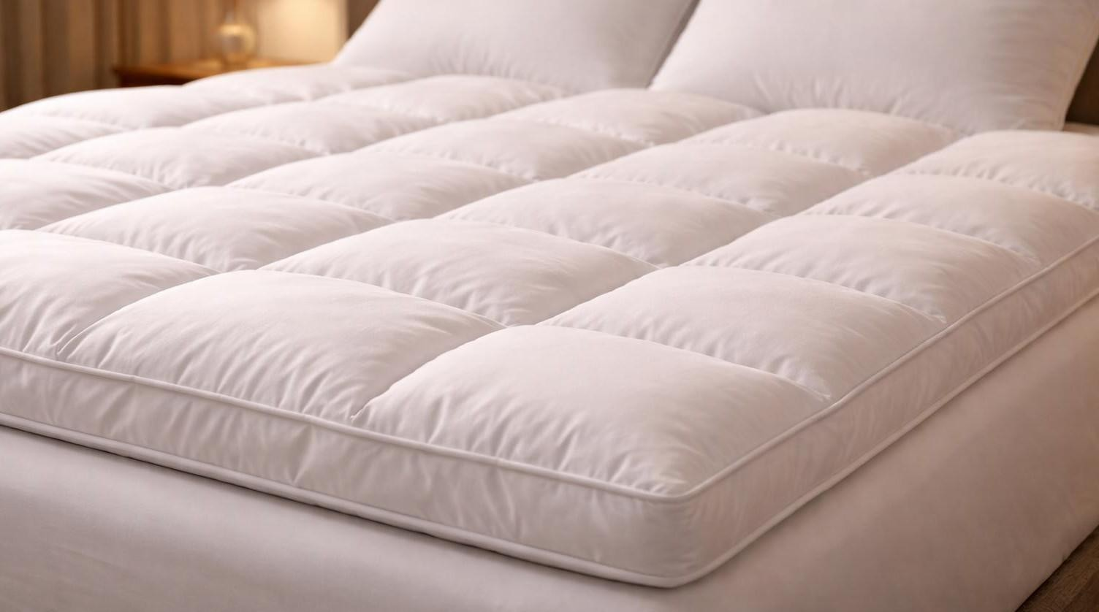
Natural insulation providing enhanced loft, breathability, and a plush sleeping surface for premium room categories.

CONSTRUCTION STYLES INCLUDED

Knife Edge Construction
Single or Double Stitch with Piping Edge Single Layer Down Construction Double Layer Down Construction

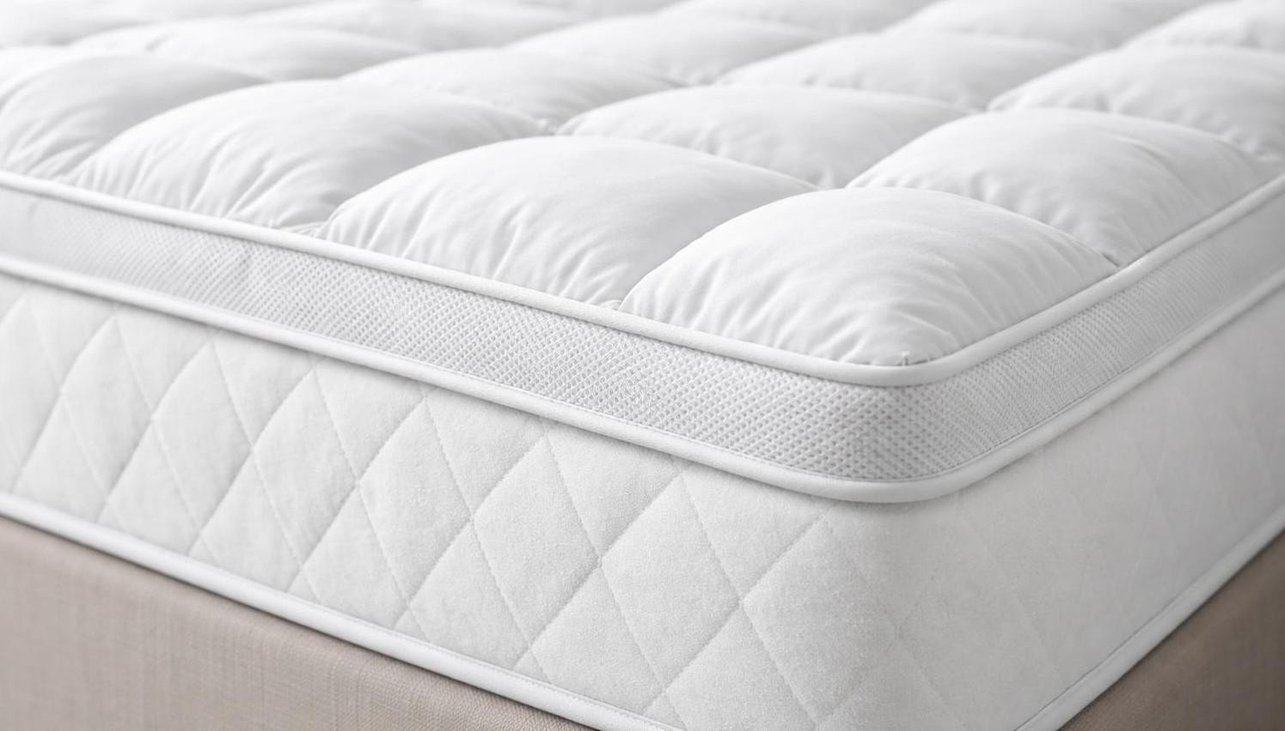

MICROFIBER MATTRESS TOPPERS
SPECIFICATIONS
Outer Fabric
Pure Cotton plain fabric
Filling
100% Microfiber Construction Knife edge stitching
Sewn-through box design
Single needle / Double-needle + piping option
Color
White (piping color optional)
Attachment
Four corner elastics
Logo & Label
Embroidery / Print / Jacquard logo
Developed for durability, consistent comfort, and ease of care, our microfiber mattress toppers provide a practical solution for hospitality environments. The microfiber filling offers balanced softness while maintaining shape and structural resilience through frequent commercial laundering.
These toppers help create a smoother sleeping surface and add an additional comfort layer without excessive weight. The construction methods ensure even filling distribution and long-term performance, making them suitable for high occupancy properties and everyday hospitality use.

CONSTRUCTION STYLES INCLUDED
Knife Edge Construction
A clean edge finish with secure inseam stitching, providing a simple and durable structure.
Single or Double Stitch with Piping Edge Reinforced edge construction with
pipingdetail, enhancing durability while offering a refined appearance.

DOWN MATTRESS TOPPERS
SPECIFICATIONS
Outer Fabric
Pure Cotton down-proof plain fabric
Filling
White or gray duck down / goose down
Down Content
5%–30% down content
Construction
Single layer down with baffle box Double layer (upper piercing + bottom baffled box)
Color
White (piping color optional)
Attachment
Four corner elastics
Logo & Label
Embroidery / Print / Jacquard logo
Designed to deliver elevated softness and enhanced sleeping comfort, our down mattress toppers provide a plush cushioning layer suited for premium hospitality environments. The natural down filling increases surface loft and breathability, helping create a refined and inviting bed presentation.
Engineered for structural stability, these toppers maintain shape and filling distribution while supporting long term performance under professional laundering conditions. This collection is ideal for luxury suites and guest rooms where additional comfort and bedding refinement are prioritized.

CONSTRUCTION STYLES INCLUDED

Single Layer Down Construction
A balanced design offering softness and flexibility while maintaining lightweight comfort. Double Layer Down Construction
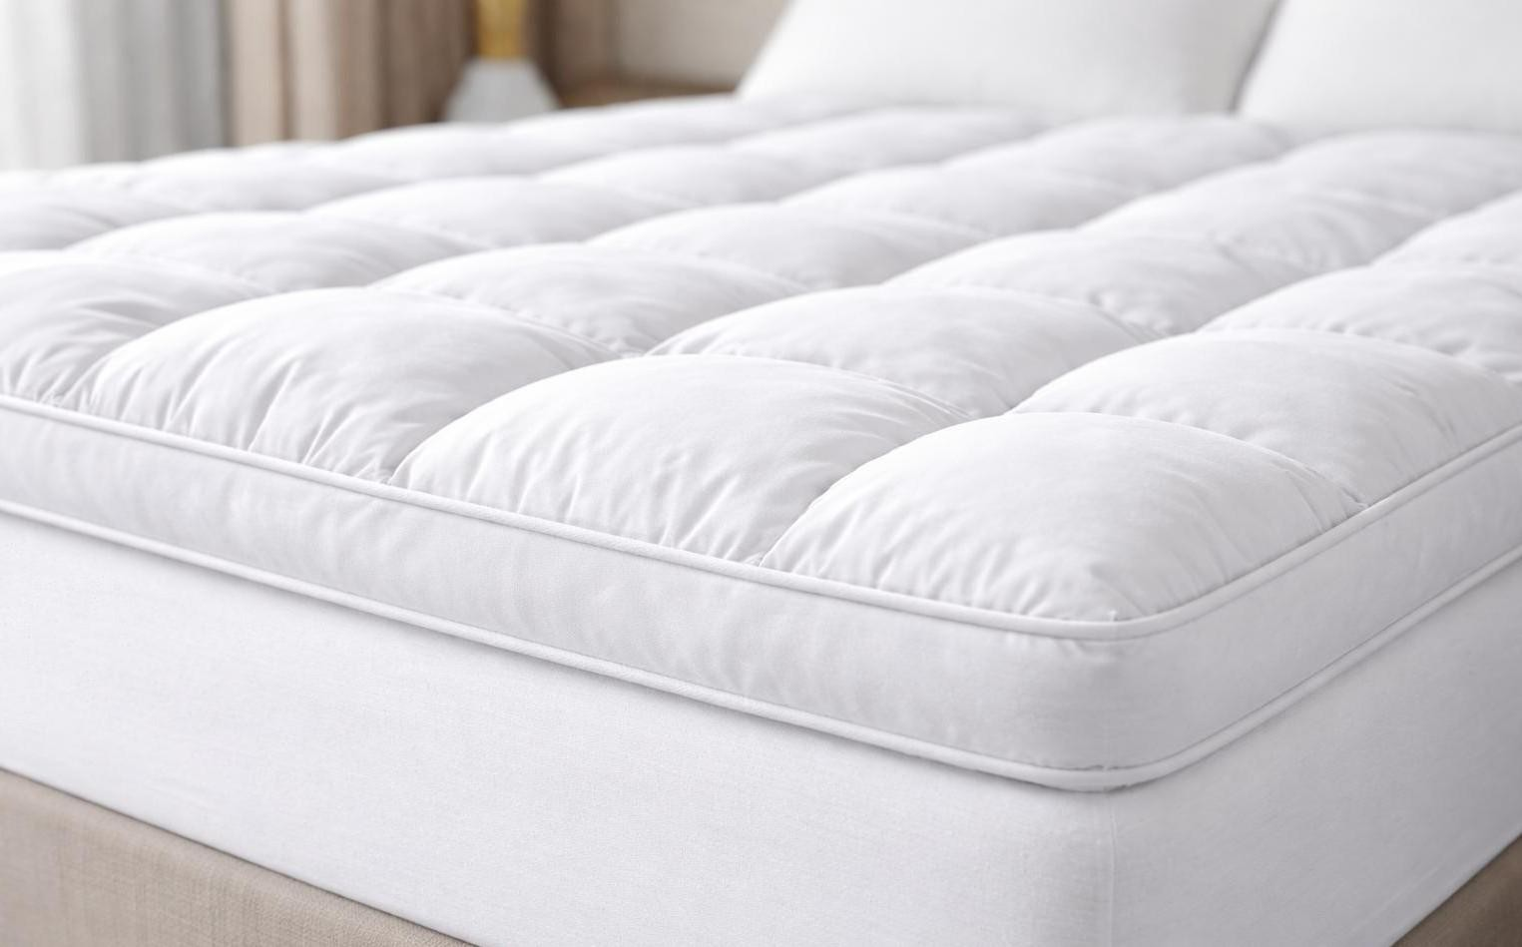
An enhanced structure providing greater loft and cushioning for premium room categories.

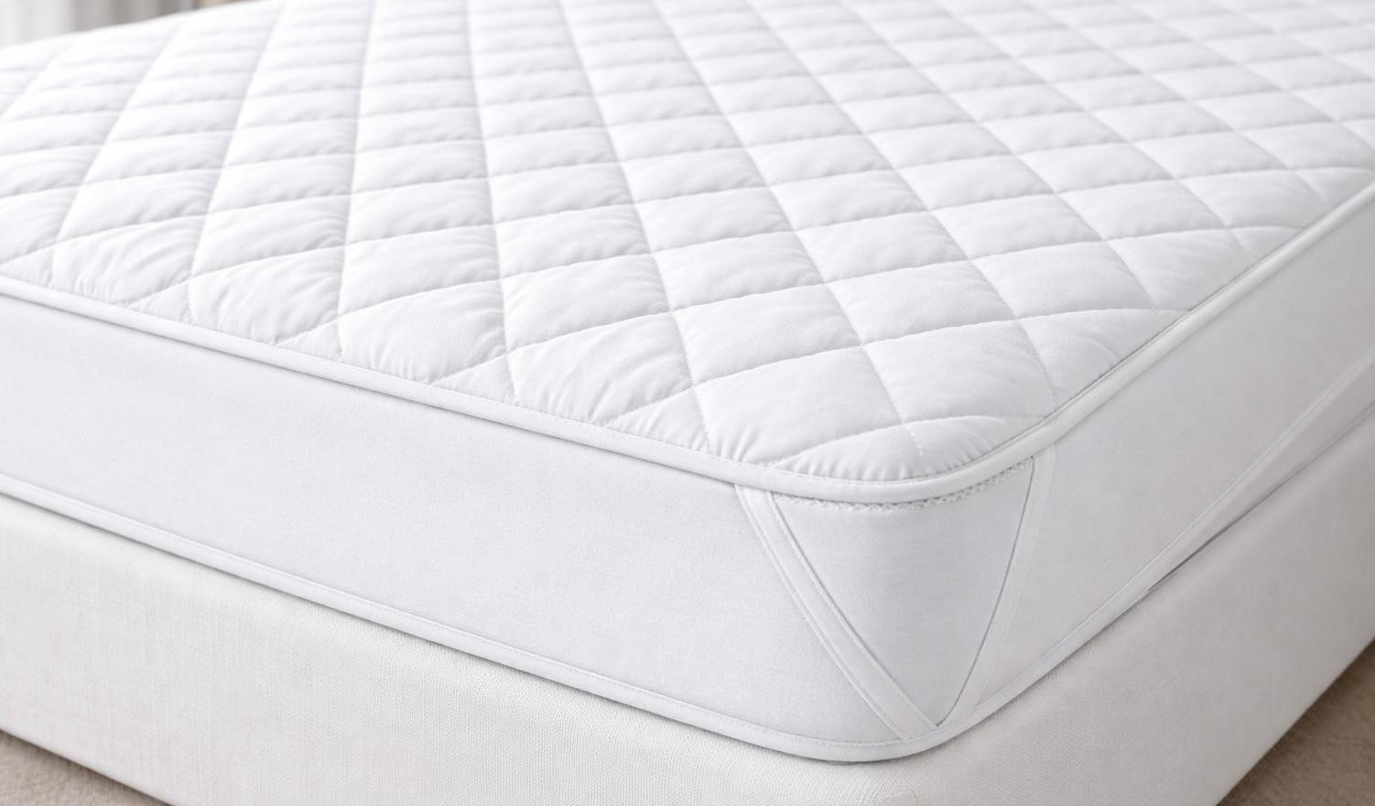

MATTRESS PROTECTOR COLLECTION
SPECIFICATIONS
Outer Fabric
Poly cotton plain fabric or Polyester plain fabric Filling
Microfiber (filling weight customized)
Construction
Quilted (diamond pattern)
Fit Options
Elastic bands on four corners
Whole elastic band (fitted / full coverage)
Color
White (size customized)
Logo & Label
Embroidery / Print / Jacquard logo
Designed to extend mattress lifespan and support hygiene standards in hospitality environments, our mattress protectors provide a protective barrier against wear, moisture, and everyday use. Positioned between the mattress and bedding layers, they help maintain mattress condition while supporting consistent bed presentation.
Engineered for durability and ease of maintenance, the collection includes construction options that ensure secure placement and long-term resilience under commercial laundering conditions.

STYLES INCLUDED
Conventional Mattress Protector
A quilted construction with elastic corner bands, providing stable coverage and surface protection. Fitted Mattress Protector
A fully fitted design with elastic edges, offering complete mattress coverage and a secure fit.

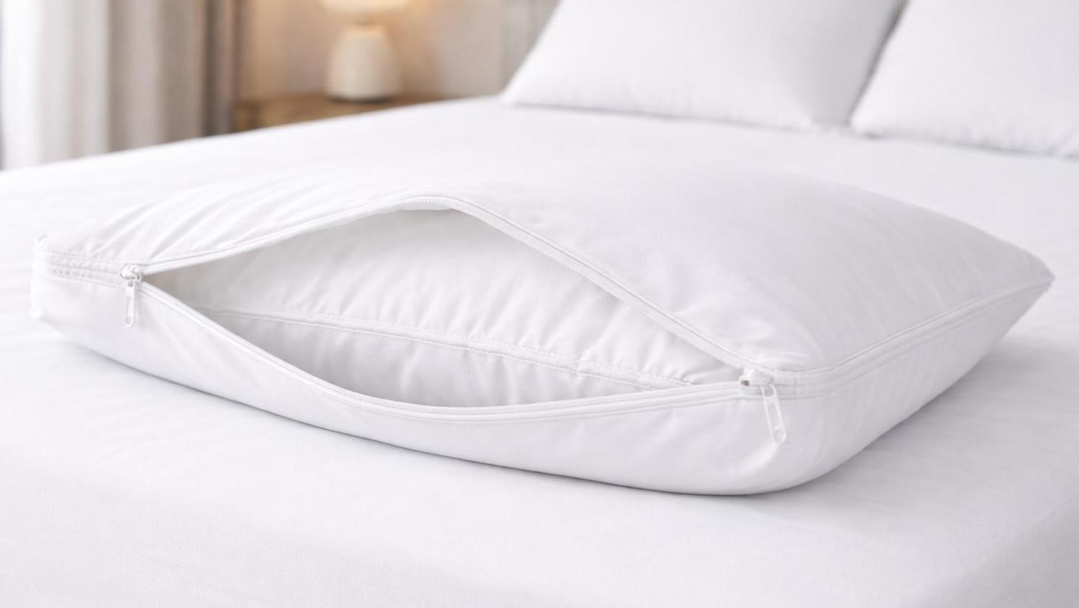

PILLOW PROTECTOR COLLECTION
SPECIFICATIONS
Material
Pure Cotton or Poly-cotton
Yarn / Thread Density
40S / 60S
200–400 TC (others can be customized)
Construction Styles
Zipper closure at side seam (no flap, no flange)
Envelope style (side opening with inner flap)
Care / Use
Machine washable
Designed to withstand frequent use
Customization
Color / Size / Logo / Pattern
Designed to maintain pillow hygiene and extend product lifespan, our pillow protectors provide an additional protective layerbetween thepillow insert and outerpillow case. They help reduce wear, protect against moisture and everyday use, and support consistent pillow performance in hospitality environments.
Constructed for durability and ease of care, the collection offers secure closure systems that maintain a neat pillow appearance while ensuring reliable coverage during repeated laundering cycles.

STYLES INCLUDED
Envelope Style Pillow Protector
A side opening design with an inner flap, providing secure coverage while allowing easy insertion and removal.
Zipper Style Pillow Protector
A fully enclosed design with a zipper closure, offering complete protection and a secure fit.

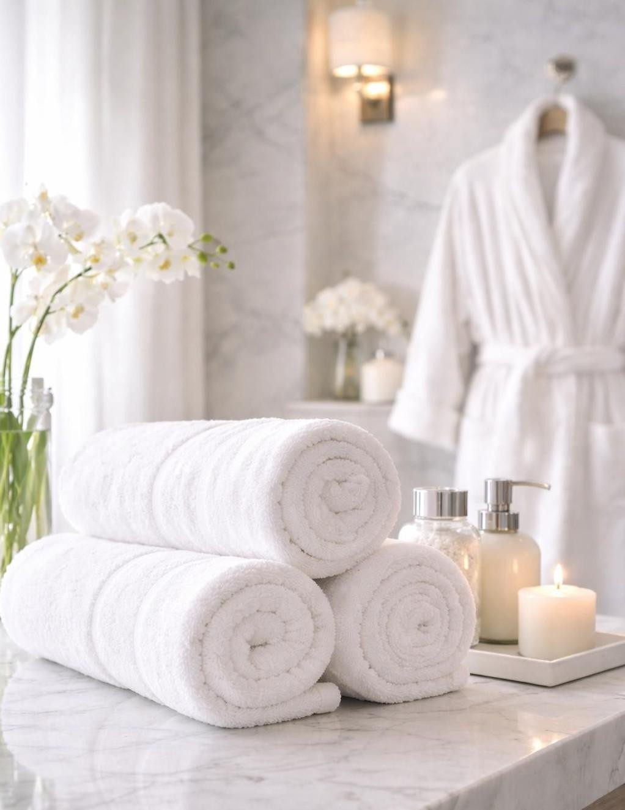

DONGLONG BATH COLLECTION

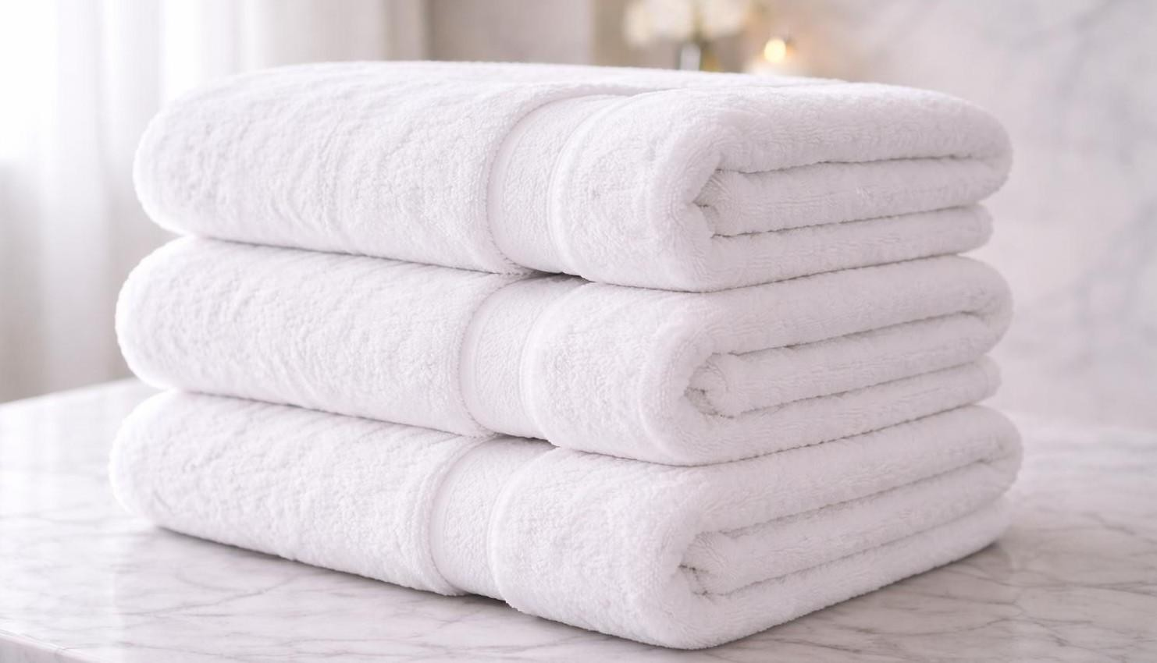

BATH TOWEL COLLECTION
SPECIFICATIONS
Material Pure cotton Pile Yarn 16S
21S two ply 32S two ply Weight
450 – 700 GSM
Color
White and customized colors
Sizes
Standard hospitality sizes or customized
Customization Logo embroidery Size
Weight
Designed for hospitality environments where comfort, absorbency, and durability are essential, our bath towel range delivers a balance of softness and structural resilience. Manufactured using high quality cotton yarns, the towels maintain thickness and texture through repeated commercial laundering, supporting consistent guest experience across room categories.
The collection includes multiple towel sizes designed for different guest uses, all engineered for rapid moisture absorption, quick drying performance, and long-term durability in high occupancy operations.
BATH TOWELS
The primary body towel offering full coverage and superior absorbency. Designed to provide a plush feel while maintaining strength and performance under frequent use. HAND TOWELS
A versatile towel size suited for vanity and wash areas. Balances softness and durability while supporting efficient drying and easy handling.
FACE TOWELS
A compact towel designed for personal use and guest amenities. Lightweight yet absorbent, maintaining softness and structure through repeated laundering.

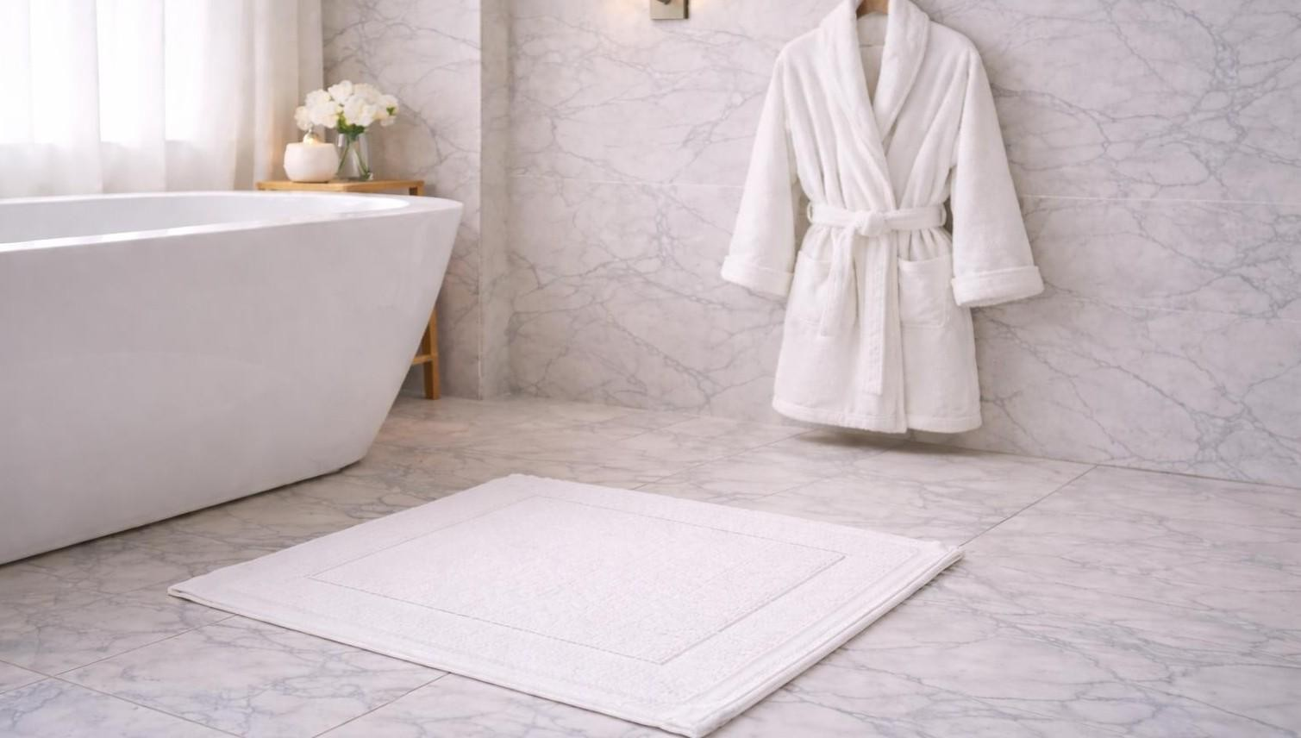

BATH MATS AND BATHROBES
SPECIFICATIONS
Material Pure cotton Fabric Types Terry
Velour Waffle
Double layer constructions
Color
White and customized colors
Sizes
Standard hotel sizes or customized
Customization Logo embroidery Size
Fabric type
Designed to enhance both safety and comfort within hospitality bathrooms, this collection combines functional floor protection with elevated guest relaxation essentials. Each product is engineered for durability, absorbency, and ease of care, ensuring long term performance in high occupancy environments.

BATH MATS
Positioned outside showers and bathtubs, bath mats provide a stable and absorbent surface that improves guest safety while maintaining a refined bathroom presentation. The construction offers high water absorption and a soft underfoot feel, supporting both comfort and hygiene standards.

BATHROBES
Designed to extend the luxury experience beyond bathing, hotel bathrobes deliver warmth, softness, and comfort. Manufactured in various fabric constructions, they provide a relaxing, spa like feel while maintaining durability and shape retention under commercial laundering conditions.

